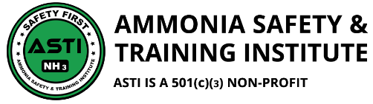
BROUGHT TO YOU BY:
32 HOUR AMMONIA SAFETY RESPONDER COURSE
OCTOBER 9-12, 2018
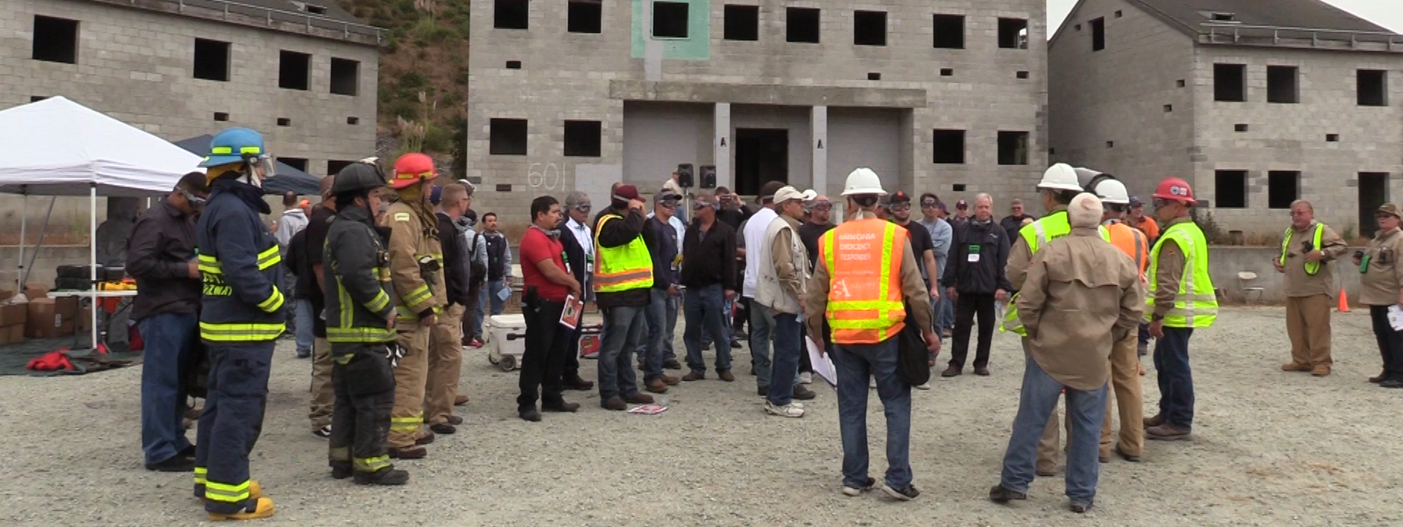
Join industrial professionals, governmental leaders, public safety responders and expert instructors for our annual
32 hour course and learn how to help make ammonia the most safely managed hazardous material in the world.
Online at:
www.ammonia-safety.com/events

Questions? Call (831)761-2935, or via email at
asti@ammonia-safety.com
What you can expect
- Learn from experts in the ammonia industry
- Live ammonia releases with hands-on engagement
- Enhanced responder effectiveness by de-mystifying ammonia
- Discussions about effective self-rescue techniques
- Understanding hazards, risks and threats of ammonia
October 9 - 12, 2018
Registration/Check-In: 7:30am to 8:00am
Class Time: 8:00 am to 4:45pm
Class ends at 12:00 pm on Friday
Location: Santa Cruz Co. Fairgrounds
2601 E Lake Ave, Watsonville, CA 95076
Early Bird pricing $1395.00 now through
July 31st, call for group discounts.
Course Cost: $1,495.00 per person: continental breakfast and lunch provided. No lunch on Friday.
*Limited scholarships available for fire service
What you’ll get
- Workbook and Critical Task Checklist
- 24 Hour Technician & 8 Hour Refresher certification options
- Best management practices for the First 30 Minutes
- Network with students, government leaders and ASTI Instructors
- Useful information to bring back to the workplace

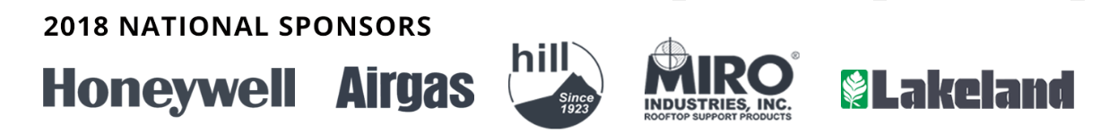
Ammonia Safety & Training Institute | P.O Box 1578 Watsonville, CA 95077
Tel: 831.761-2935 | Fax: 831.761.2876 | asti@ammonia-safety.com | www.ammonia-safety.com

